**Methods as props(15):**

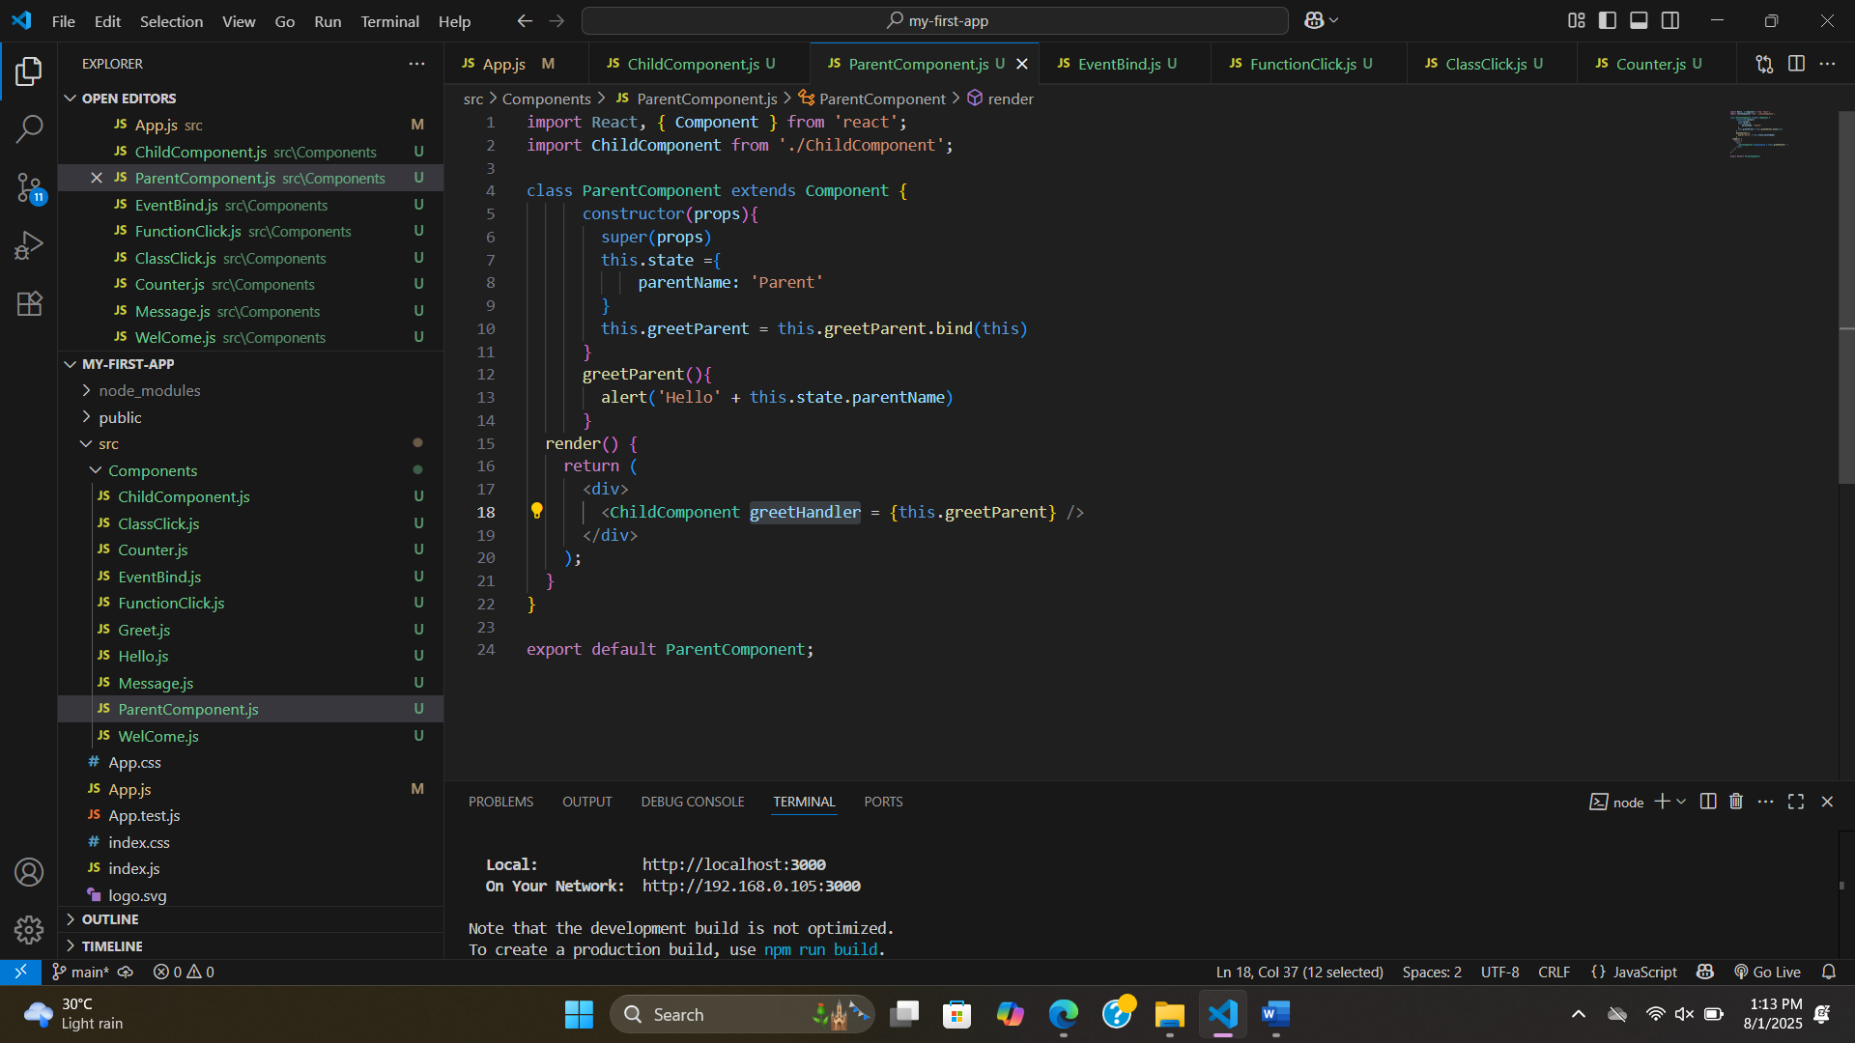

**Passing a parameter when calling a methods:** 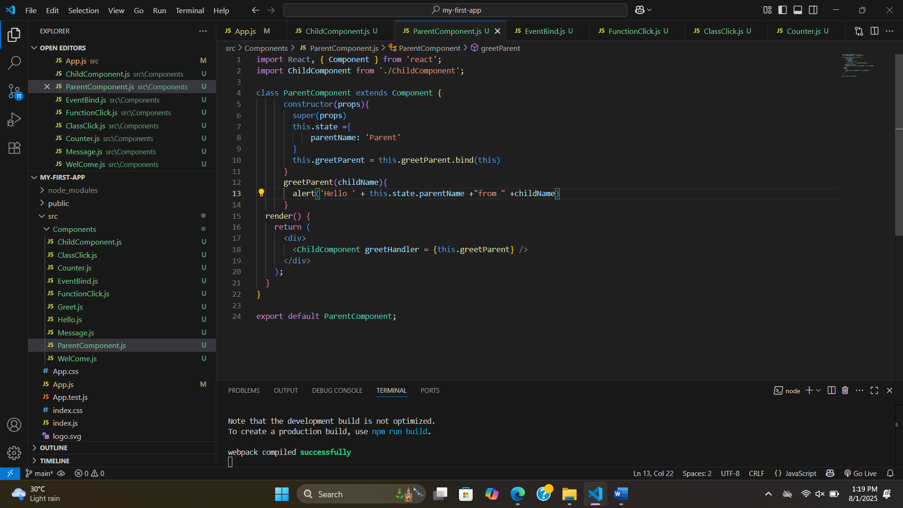

**Conditional Rendering(16):**

**1.if/else**

**2.element variable**

**3.ternary conditional operator**

**4.short circuit operator**

**.if/else:**

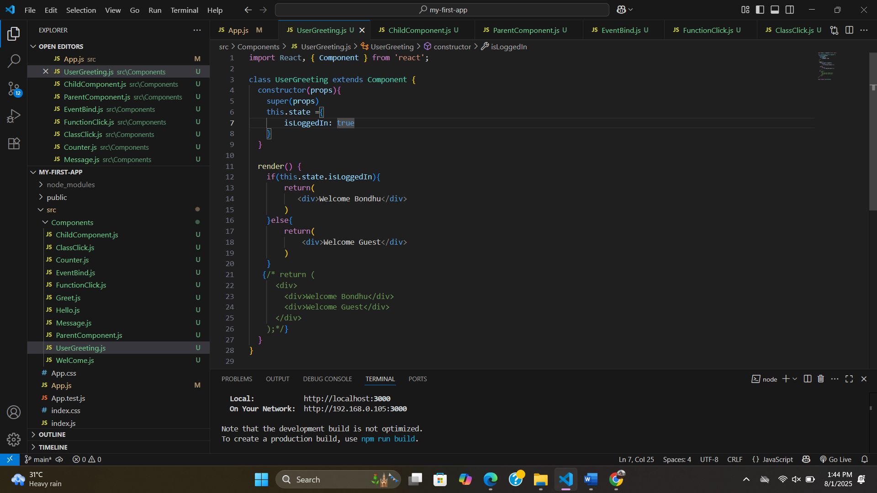

**.element variable:**

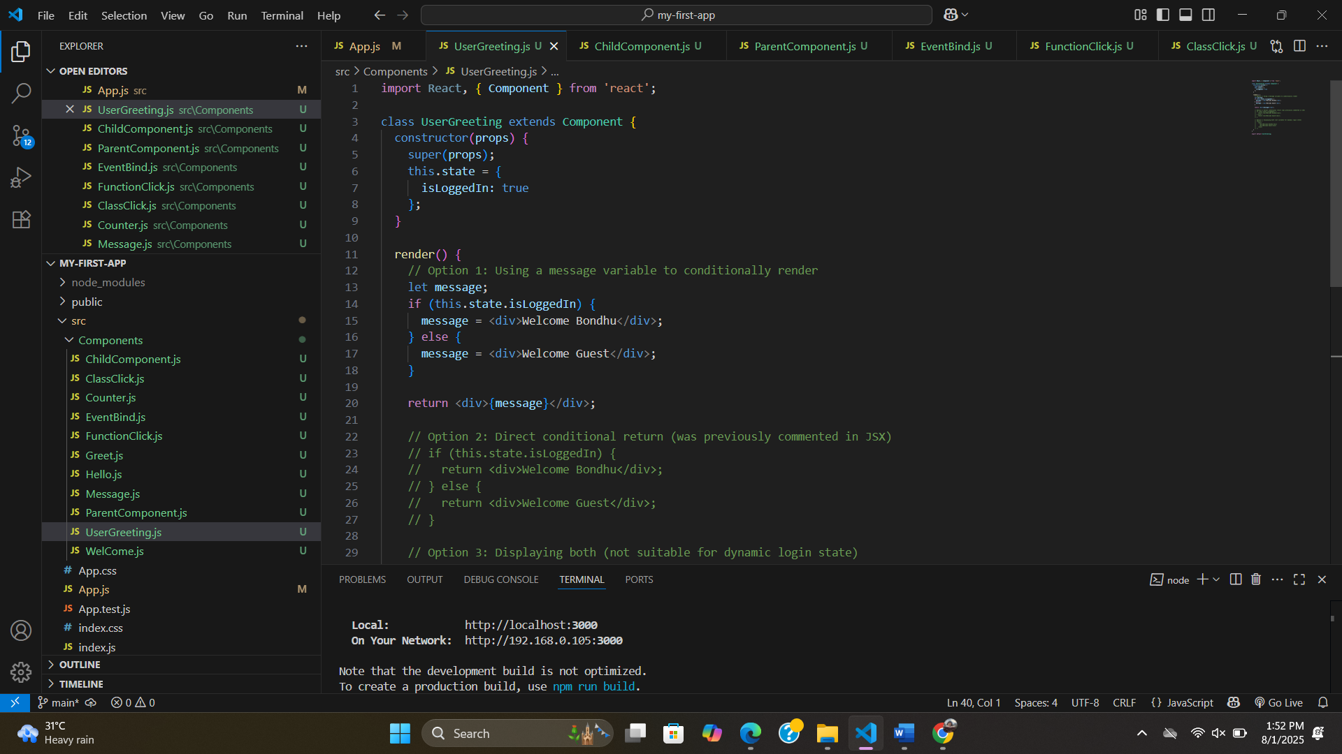

**.ternary conditional operator:(mostly use)**

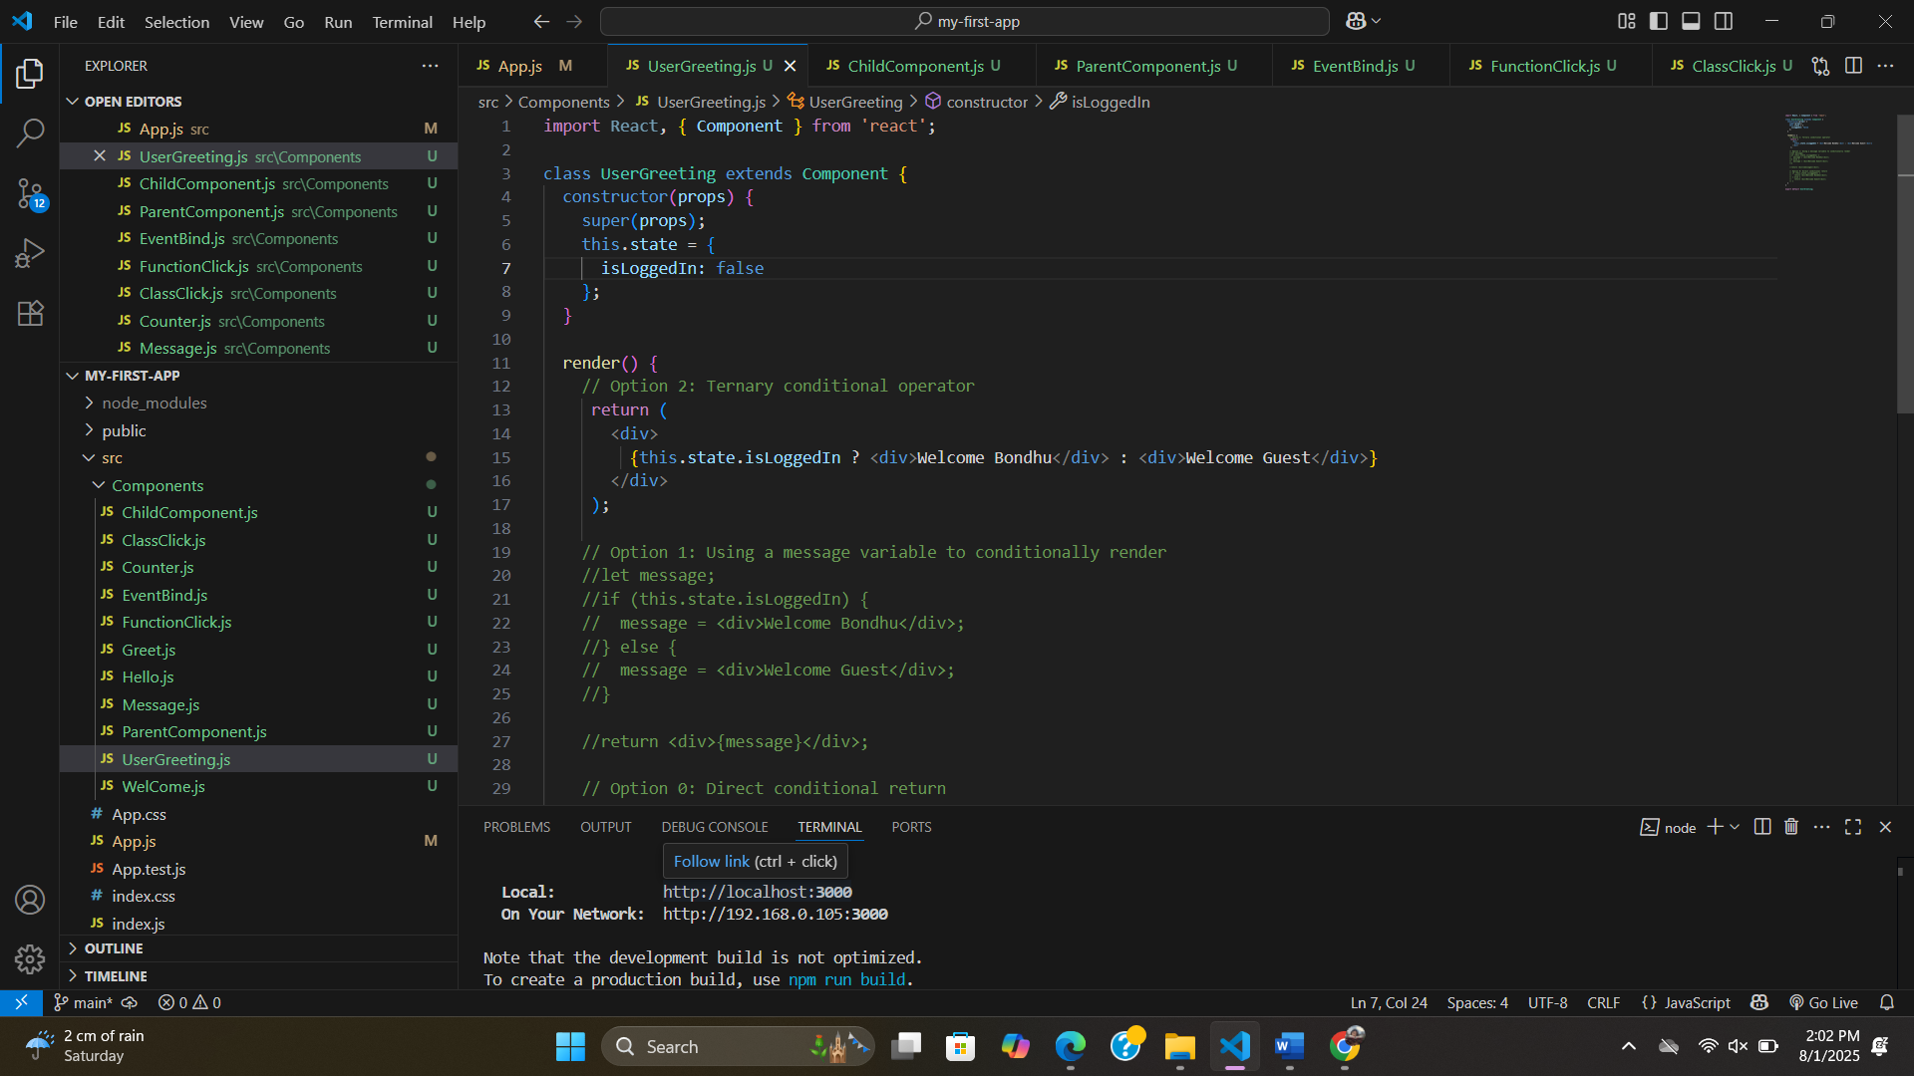

**. short circuit operator:**

